Darryl Rusli

Capstone project

Contents

Problem Statement 2

Industry / Domain 3

Data 4

Pipeline 5

EDA 5

Modelling 6

Model Comparison 7

Alexnet Model Evaluation 7

Summary 7

References 8

Library 8

Resources of the of the project 8

Capstone Project Document

# Problem Statement

The aim of Labelled Face in the Wild is to investigate the problem of unconstrained face recognition (faces that demonstrate large range of variation). This includes:

* Lightning
* Pose
* Expression
* Race
* Ethnicity
* Hairstyles
* Quality of camera
* Focus

The reason of the problem of unconstrained face recognition is valuable to be addressed is that pair matching problem is one of the most foundational face recognition problems.

The tools that they are currently use for face recognition is the Viola-Jones detector as a filter which has limited number of side views of faces such as few views form above and bottom. However, there are large variety of pictures present.

Labelled face in the Wild dataset is one of the important face data in the world and has been by many known established companies such as Google and Facebook to test the accuracy of facial recognition.

The researchers created this dataset to help the research community to advance the face verification system.

The problem of Unconstrained Face Recognition has been addressed. All of the images have been detected by Viola Jane Detector which resulted minimizing the error by manually eliminating the False Positive results.

# Industry / Domain

Labelled Face in the Wild was developed by the researcher team from College of Information and Computer Science of *University of Massachusetts of Amherst.*

College of Information and Computer Sciences, Professor along with CICS alumnus Gary Huang have received the Award of Mark Ervingham Award from ICCV sponsored by IEEE for their award for their work in Labelled Face in the Wild and the award is given annually by Technical Committee on Pattern Analysis and Machine Intelligence of the IEEE Computer Society. The Dataset have been used by known establish company like google and face to test face-recognition accuracy.

Erik Learned-Miller and the other research team member Gary B Huang and Tamara Berg view Unconstrained Face Recognition Problem as one of the facial recognition problems. Unconstrained Face Recognition is a large variation that includes variation of pose, lighting, pose, expression, background, race ethnicity, age, clothing, hairstyles and other parameters.

Learned-Miller and The Research Team aim of making the database is to make the advance facial recognition. Therefore, their expectation is facial recognition technology or machine learning model/algorithms that works very well when it comes to do the facial recognition accurately

# Data

The data was developed by Researchers at University of Massachusetts Amherst CICS where the data was sourced.

The data contained:

* 1288 Samples
* 7 Target classes
* Height: 298
* Width: 224
* Train: 966
* Test: 322
* Greyscale Image (1 channel)

The data is not reliable as there are many groups that is not represented well such as no female, no children, no babies, and no people of 80.

The dataset has no null as it is an image dataset.

As it is a public data (scikit-learn dataset), I generated the data by loading the command fetch_lfw_people() command with the parameter set to specific number so the size is 298 x 224.

# Pipeline

Data Pipeline:

1. Stakeholder
2. Context
3. Questions
4. Data description
5. Image pre-processing
6. Model Evaluation
7. Model Recommendation

**Reusability**: The pipeline will not be necessarily reusable as minor change to the data pre-processing could happen.

# EDA

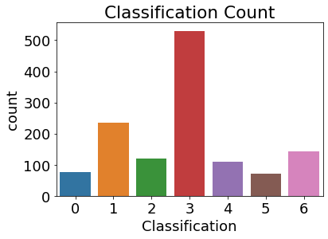

The data/target is imbalanced classification 3 which represents George W Bush cover the majority of the whole data which is the only limitation.

|  |  |
| --- | --- |
| Classifications | Target Name |
| 0 | Ariel Sharon |
| 1 | Colin Powell |
| 2 | Donald Rumsfeld |
| 3 | George W Bush |
| 4 | Gerhard Schroeder |
| 5 | Hugo Chavez |
| 6 | Tony Blair |

# Modelling

It is a reshaped to rectangular shape with height and width of 298 x 224. However, since the 3 chosen CNN models require the square shape so I cropped the image to square with height and width of 224 x 224. Additionally, I normalised the features by x/255.0 before reshaping.

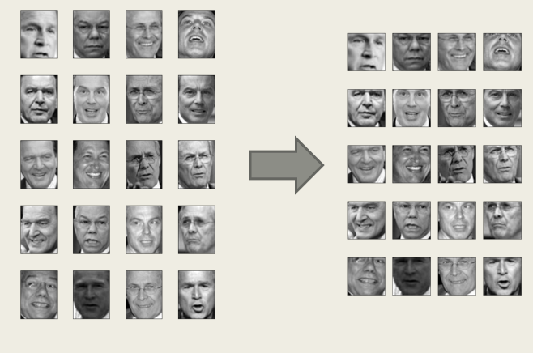

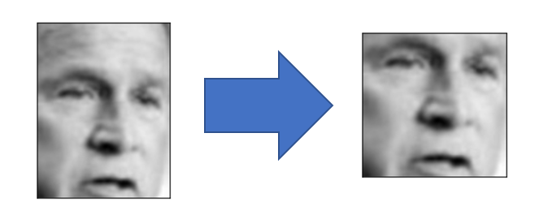

# Model Comparison

|  |  |  |  |
| --- | --- | --- | --- |
| Models | Accuracy | Loss Value | Training Time |
| Alexnet | 82% | 0.85 | 2 hours 13 minutes |
| ResNet 50 v1 | 61% | 1.75 | 5 hours 31 minutes |
| VGG16 | 65% | 7.6 | 6 hours 15 minutes |

## Alexnet Model Evaluation

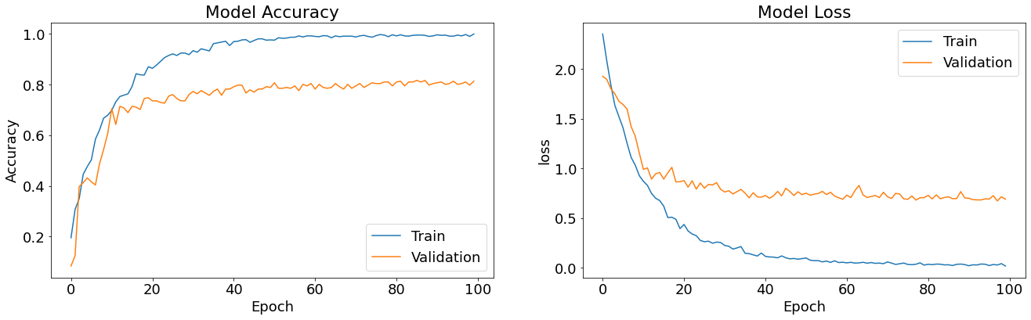

***Results***: From the 3 models that have been trained and tested, Alexnet would be recommended as the model performs well on facial recognition accuracy, low loss value and train shortest compared to the other 2 models.

# Summary

The model (Alexnet) can be able to do face recognition with 82% accuracy and low lost value and train shortest compared to the other 2 models.

Viola-Jane detector were used to do face-recognition which minimize the error by eliminating the false positive. However, despite the limited number views exists such as limited sides views of faces, and few views from above and below.

Future Applications:

* Collecting more observations and groups such as children, babies, people over 80 and women so that way the LFW can provide more evidence that the model is accurate to do face recognition
* Implementing other CNN Models like Faster R-CNN Resnet V1, CenterNet Resnet50 V2, and ResNet 29 and test the CNN Model on the data with additional group types as mentioned above to do the Face Recognition Accuracy.

# References

## Library

* NumPy
* Keras
* TensorFlow
* Scikit-Learn (To load the Labelled Face Dataset):
  + <https://scikit-learn.org/stable/modules/generated/sklearn.datasets.fetch_lfw_people.html>

## Resources of the of the project

<http://vis-www.cs.umass.edu/lfw/>

<https://people.cs.umass.edu/~elm/papers/lfw.pdf>

<https://www.umass.edu/news/article/cics-professor-erik-learned-miller>